**Market Maker Trap False Breakouts**

Market Maker Trap: False Breakouts

False Breakouts Above Price Consolidations:

This condition generally manifests in Primary Bearish Markets.

At some measure of Equilibrium in Price, the market will move into a trading range. Neophyte Traders or Breakout Traders will bracket the trading range in price with orders. Market Makers will typically send price above the range to neutralize Buy Stops.

False Breakout Below Price Consolidations:

This condition generally manifests in Primary Bullish Markets.

At some measure of Equilibrium in Price, the market will move into a trading range. Neophyte Traders or Breakout Traders will bracket the trading range in price with orders. Market Makers will typically send price below the range to neutralize Sell Stops.

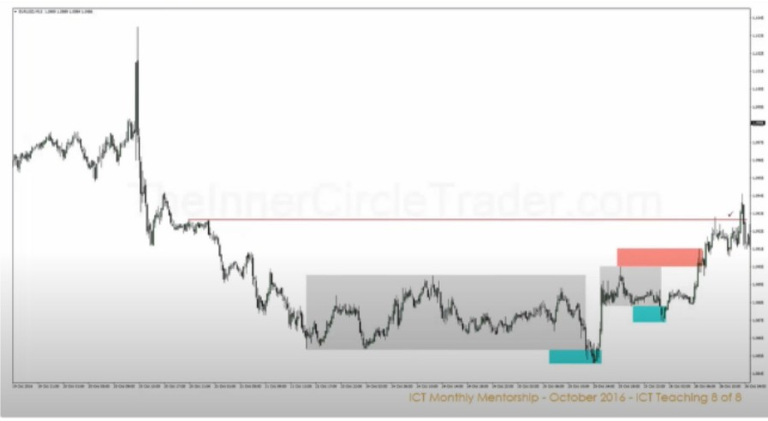

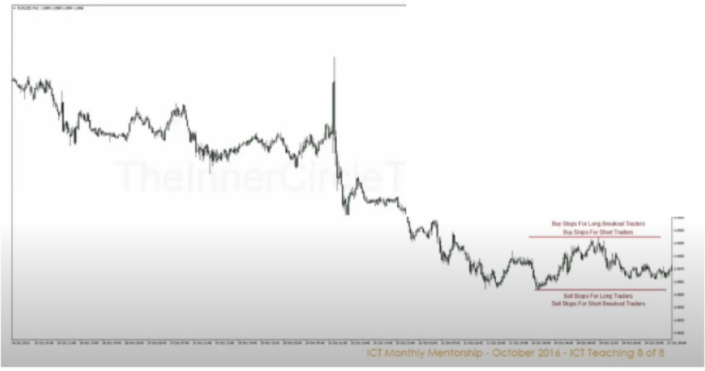

·-

r

Primarily the volume is in the bodies of the candle, so the liquidity is below/above the bodies of the candles

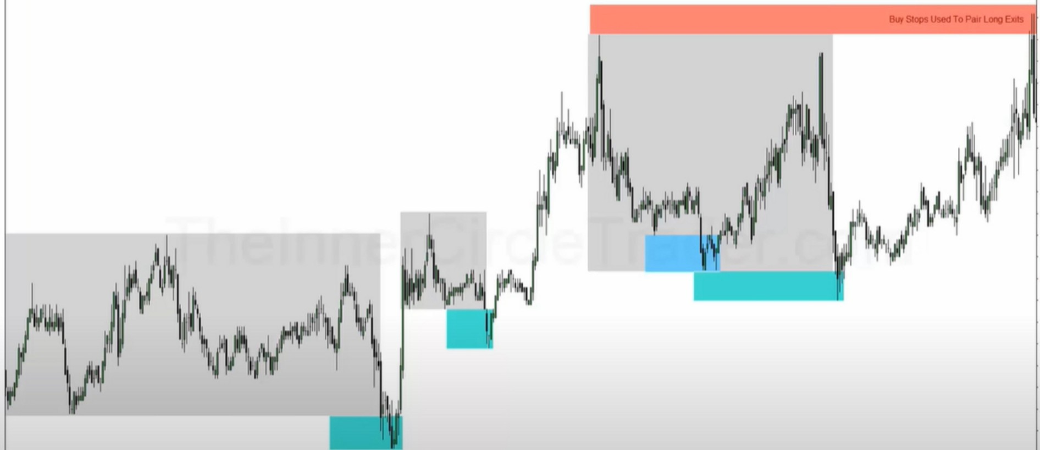

Theyre providing liquidity



The market will always seek liquidity

Where is the most recent area of liquidity that has been untapped with the least resistance to it? Thats your bias

Think like a market maker

Do they want to trick sellers or buyers?

Study when they go in consolidation and what side are they reaching for and where is the market going after it happens

So when were bullish and market goes into consolidation expect every move below the consolidation to be a break out and see if were getting a willingness to go higher afterwards

This is the easiest way to see if were in a bullish profile

Arjo I Twitter, lnstagram I Linktree

Linktree. Make your link do more.

I https://1.co/HhmmTN1fUI

JavaScript is not available.

"# https://twitter.com/arjoio